SOURCE:

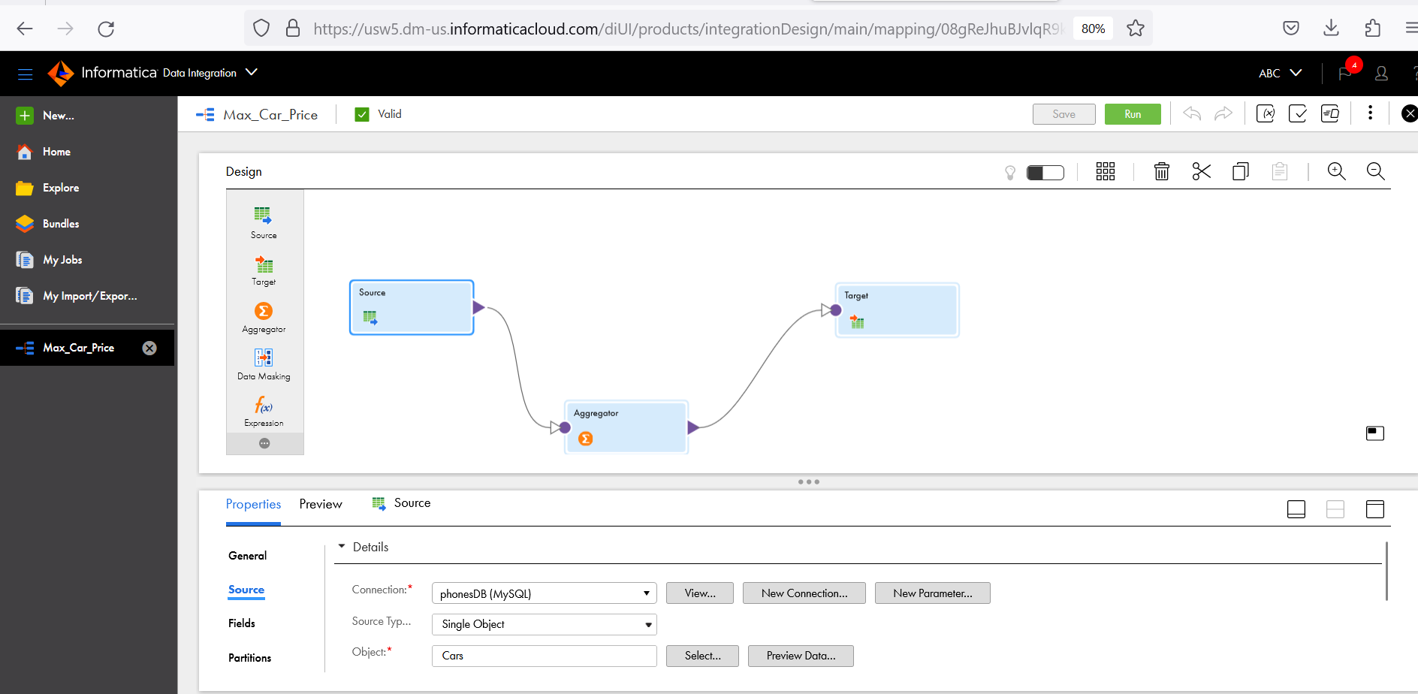

Agregate:

Target:

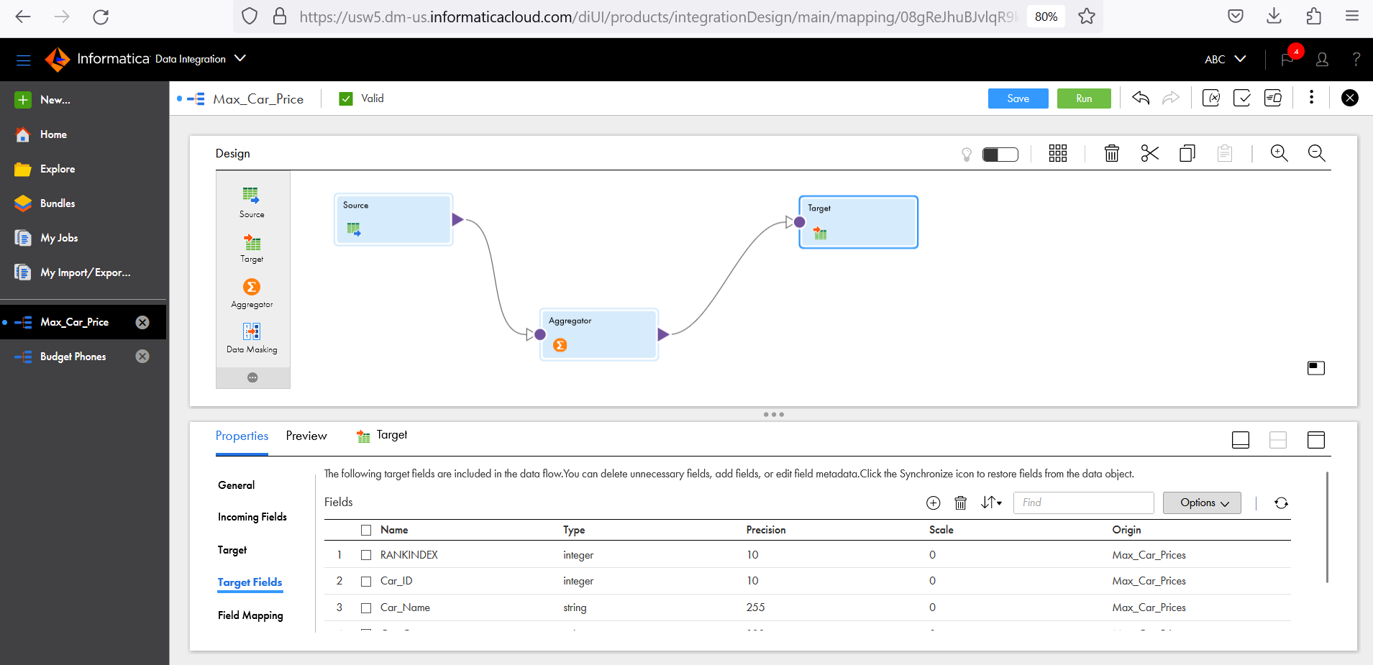



Created new table

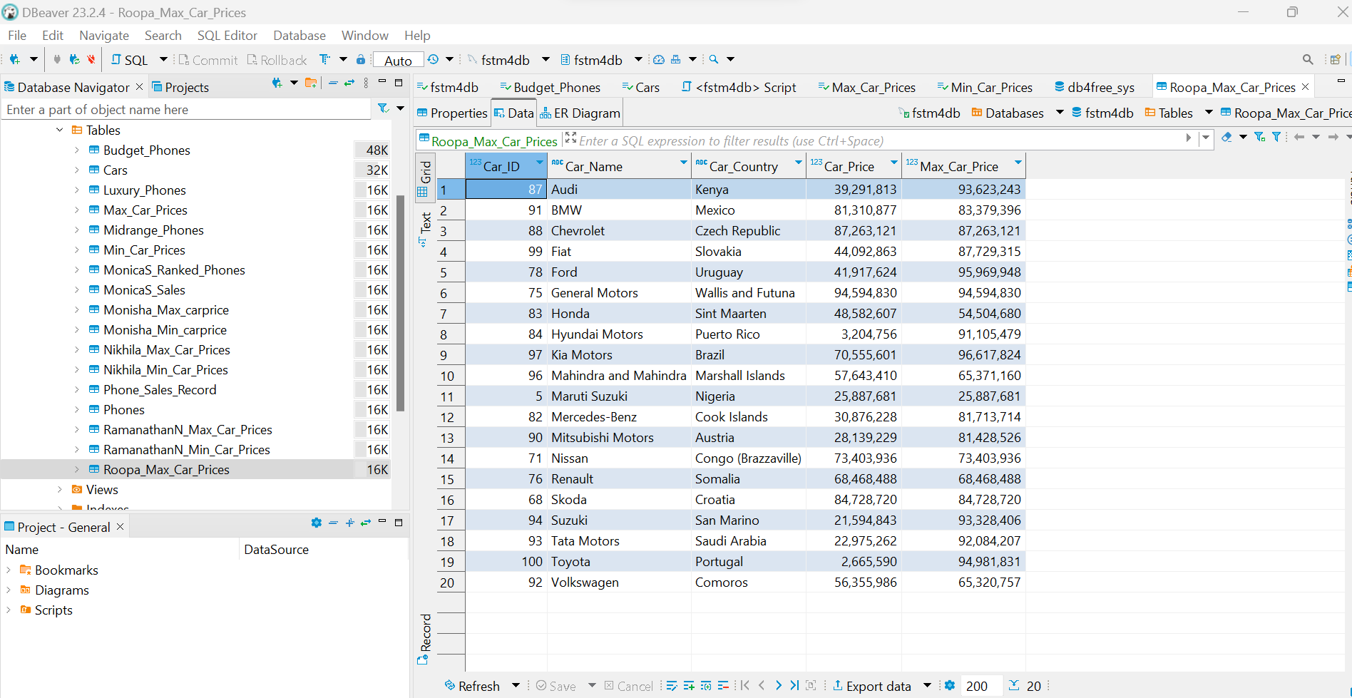



Source:

Aggregate:

Target: Create New Table

My Job

View records

